

**Review Guide**

**JAMARADO**

**PLAY MUSIC. ENJOY LIFESTYLE. DISCOVER CULTURE.**

**Price: £2.99 per month or £24.99 annual**

# [www.jamarado.com](http://www.jamarado.com/)

## Click here for APPLE APP STORE/ GOOGLE PLAY

[**http://bit.ly/2scUQVL**](http://bit.ly/2scUQVL)

FOR ALL PRESS & INTERVIEW ENQUIRIES PLEASE CONTACT

Karen Proctor – Founder [karen@jamarado.com](mailto:karen@jamarado.com) 07879 454 735

**JAMARADO – THE EASY-TO-USE, SIMPLE TO CHOOSE, REGGAE & DANCEHALL MUSIC APP**

### Simply select one of our unique music zones to access over 5k hand selected tracks covering all of Reggae’s most loved genres. We offer simple radio x streaming, no ads, no fuss, no chat, no fiddly playlists.

Just pure music. Select and flow.

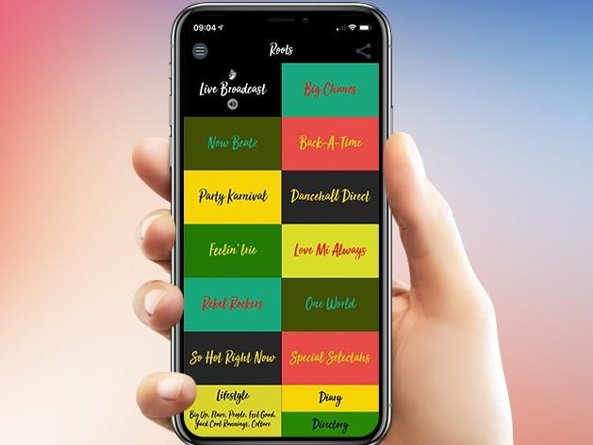

**JAMARADO FEATURES….**

**THE ULTIMATE REGGAE COLLECTION** Offering twelve music zones, covering reggae’s many & varied genres. From the 60s to now, we’ve selected the best from ska to dancehall, roots to rocksteady, reggae rap to dub, lovers rock to afro-beats plus upcoming tunes from across the globe.

**DIRECTORY** Six sections, covering worldwide travel, food, wellbeing, record stores, culture & home interiors, with a specially curated list of our top picks for each one. **DIARY** A month by month quick & easy guide showing what’s on & where to go - featuring Reggae festivals, concerts & special events across the globe.

**LIFESTYLE** In depth interviews with Musicians, Artisans & Entrepreneurs, special features on cultural experiences, food & fashion, book & film reviews.

**AVAILABLE ACROSS ALL DEVICES**– supporting an on the go lifestyle, accessible across the globe - you can listen in the car, on the way to work or at your desk and while entertaining friends. JAMARADO is designed to work on phones, tablets, laptops, PCs & primed for any Bluetooth speaker too.

**USEFUL LINKS**

**Jamarado Website:** [**www.jamarado.com**](http://www.jamarado.com/)

Join us …

   

**QUESTIONS?** If you have any questions, please don’t hesitate to contact Karen Proctor, founder

of JAMARADO – [karen@jamarado.com](mailto:karen@jamarado.com) or 07879-454735